Flashing Large Mammals  
Quantifying the effect of white LED flash on camera trapping detection rates  
   
   
   
   
Thesis submitted for the degree of Master of science in Bioscience:  
Ecology and Evolution  
60 Credits

Torgeir Holmgard Valle

# Introduction

Estimating number of animals are central in the population ecology, and has always been under development in order to get accurate, reliable ways of conducting surveys.

Counting mammals directly is difficult, as they are shy, elusive, and mainly night active. Some methods involve walking one or several men in a row, scaring up animals, and counting them as they flee. Still, any such method is prone to undercounting, due to low visibility in dense forests and lack of focus from observers after a while. There are other, indirect methods, like counting tracks or calls during the mating season, but these work best when the target species has a large density.

In snowy areas, like Norway, counting snowtracks has been a popular method. Snow track counts has the advantage of highly visible tracks, and a somewhat accurate dating of the tracks to the last snowfall, as old tracks vanish. However, lately there has been a variable lenght of the snow season in southern Norway, which has made the snow track counts unpredictable and difficult to conduct at a consistent time of year.

Therefore, looking for new methods, the Norwegian Institute of Nature Research (NINA) has started to use camera traps (CTs). CTs have been developing fast, and become quite affordable. They offer a consistent, standardised sampling method which also records date, hour and, in some instances, temperature.

CTs normally use infra-red (IR) light to photo-capture animals, which is invisible to the human eye, but has been shown to be visible to several other mammals (). However, the lack of sharpness and detail from IR photos limit the information we can retrieve from them, e.g. individual variation in coat patterns which can be used in capture-recapture models to accurately estimate population numbers.

The need for more detail has led to the usage of white light flashes. CTs with white light flash comes with either white xenon or white light-emitting diode (LED) technology, where xenon provides the sharpest photos, but has the disadvantage of long cool downs after each photo (minimum of 22 seconds in Heinrich 2020).

Naturally, white light is highly visible to all land dwelling mammals, and will likely affect the animals to some extent (eg. startle, stress) which in turn could bias the data we collect. Problems related to CT awareness and behavioural changes have already been discussed by many (). Beddari (2019) showed that grey wolfs (*Canis lupus*) in Norway tend to shy away from sites where a white LED CT was used, whilst the Eurasian lynx (*Lynx lynx*) seemed less bothered. Heinrich (2020) studied roe deer and red deer’s responses to IR, black and white flash, but used a xenon white flash, which has a long cool down, and hindered any meaningful comparisons with the other flash types.

In this study, I will attempt to quantify how the usage of white LED flash affects the detection rate of *the most common large mammal species in the area*. White LED CTs have similar recovery speeds to that of regular IR CTs, as both utilize LEDs as flashes, which makes them well fit for meaningful comparisons.

###### Hypotheses

(H0): Usage of white LED flash will have no effect on the detection rate of any species.

(HA): Usage of white LED flash will stress one or more species in general, and therefore lower the detection rate of the stressed species. The effect will likely vary in extent between species.

# Method and materials

## Study area

The mean annual temperatures ranges from 2-6 , precipitation lies between 700-1500mm and growing season length lies between 170 - 190 days (). Topography is predominantly flat towards the south, and more rugged and elevated towards the north. The landscape is a mosaic of forest and agricultural areas, divided with a wide network of gravel roads. The area is situated in the southern boreal and the boreonemoral zones. Norway spruce (*Picea abies*) and Scots pine (*Pinus sylvestris*) make up the dominating boreal coniferous forests, with frequent presence of silver birch (*Betula pendula*) and downy birch (*Betula pubescens*), then aspen (*Populous tremula*), alder (*Alnus incana*) and black alder (*Alnus glutinosa*).

The study area (59.36-60.45° N, 9.31-11.13° E) extends over much of the southeastern parts of Norway in municipalities Flå, Krødsherad, Sigdal, Ringerike, Modum, Hole, Lier, Øvre Eiker, Asker, Oslo, Enebakk, Indre Østfold, Våler, Råde, Moss, Frogn and Vestby in Oslo and Viken counties. The climate has a continental character due to rain shadows of the mountain ridges from the west.

## Study species

The species I’ll focus on in this thesis are the species that most frequently was observed *(>50 events)*, excluding farmed animals (e.g. cattle), humans and dogs, and grouped categories of animals (e.g. birds). That left nine species, namely roe deer (*Capreolus capreolus*), red fox (*Vulpes vulpes*), badger (*Meles meles*), moose (*Alces alces*), red deer (*Cervus elaphus*), red squirrel (*Sqiurus vulgaris*), hare (*Lepus timidus*), European pine marten (*Martes martes*) and lynx.

## Study design

The Norwegian Institute of Nature Research (NINA) started with CTs to substitute snow track surveys of lynx family groups, after several years of varying snow season length in south eastern Norway (). The surveys are integrated in a coordinated Scandinavian science project on lynx, called Scandlynx. I was given access to CTs used in the Scandlynx project, and chose 60 sites to get a substantial amount of data, while doing a feasible amount of field work besides my master courses at the university. For logistical reasons, I chose the sites closest to Oslo which weren’t already equipped with white LED flashes. Instead, these CTs were equipped with infra-red flashes, and I will refer to them as the *IR CTs*.

The IR CTs had been installed on trees 1-3 m from wildlife, human or tractor paths, 30-160 cm above ground level, and their distance from houses or roads varied to a large extent. They were set up and handled by people from NINA and, at the sites further from Oslo, by local volunteers. The installation of the cameras did not follow a strict protocol, nor were their locations chosen randomly. The overall placement was systematic as decided by NINA, then there was a deliberately-biased placement of the CTs put up in areas where the individual handler deemed it most likely to photograph lynx, and hence, based on a combination of site accessibility and expectations of animal occurrence.

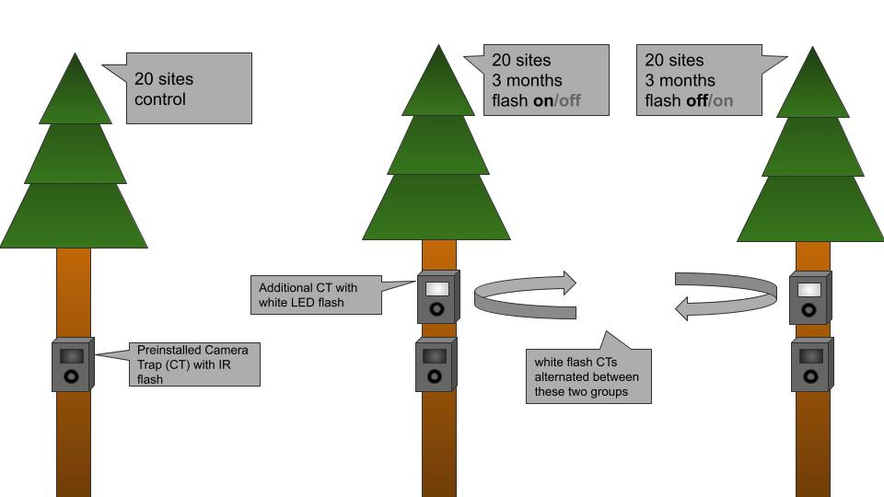

Experiment setup I chose 60 sites with preinstalled Infrared Camera Traps (IR CTs) for my study, and divided them into three groups, where the first group remained unchanged (control group), and the two other alternated on having additional white LED CTs present (treatment groups). Four sites were removed from the analysis due to large gaps in the data, etc.

I divided the sites randomly into three groups of 20 sites. The first group remained unchanged as a control, and the remaining two groups (hereby referred to as the *treatment groups*) were equipped with an additional white LED camera (hereby referred to as the *wLED CTs*) in alternating 3 month-periods, as illustrated in figure. Periods when an additional wLED CT was present, I will refer to as *wLED periods*. Periods when the wLED was absent, I will refer to as *IR periods*. All periods from the control group, I will refer to as *control periods*. Note that control periods also are periods with only IR CTs present, but they differ from the IR periods in that there never was a white LED present at these sites.

I set up all wLED CTs above the IR CTs already in place (installation examples in figure [fig:cam_ex_main]), using an electric drill. I used short logs to adjust the angle of the wLED CTs, aligning it to the IR CTs field of view. Vegetation obstructing the view of any camera was removed at setup, or when noticed during a later visitation (e.g. tall grass during summer).

At one site the IR camera had been installed so far above ground level that I chose to position the wLED CT below the IR CT. The camera boxes containing the wLED CTs remained at each site untill the end of the survey. Note that the second treatment group had no extra boxes before the start of their first wLED period in May 2019.

.5 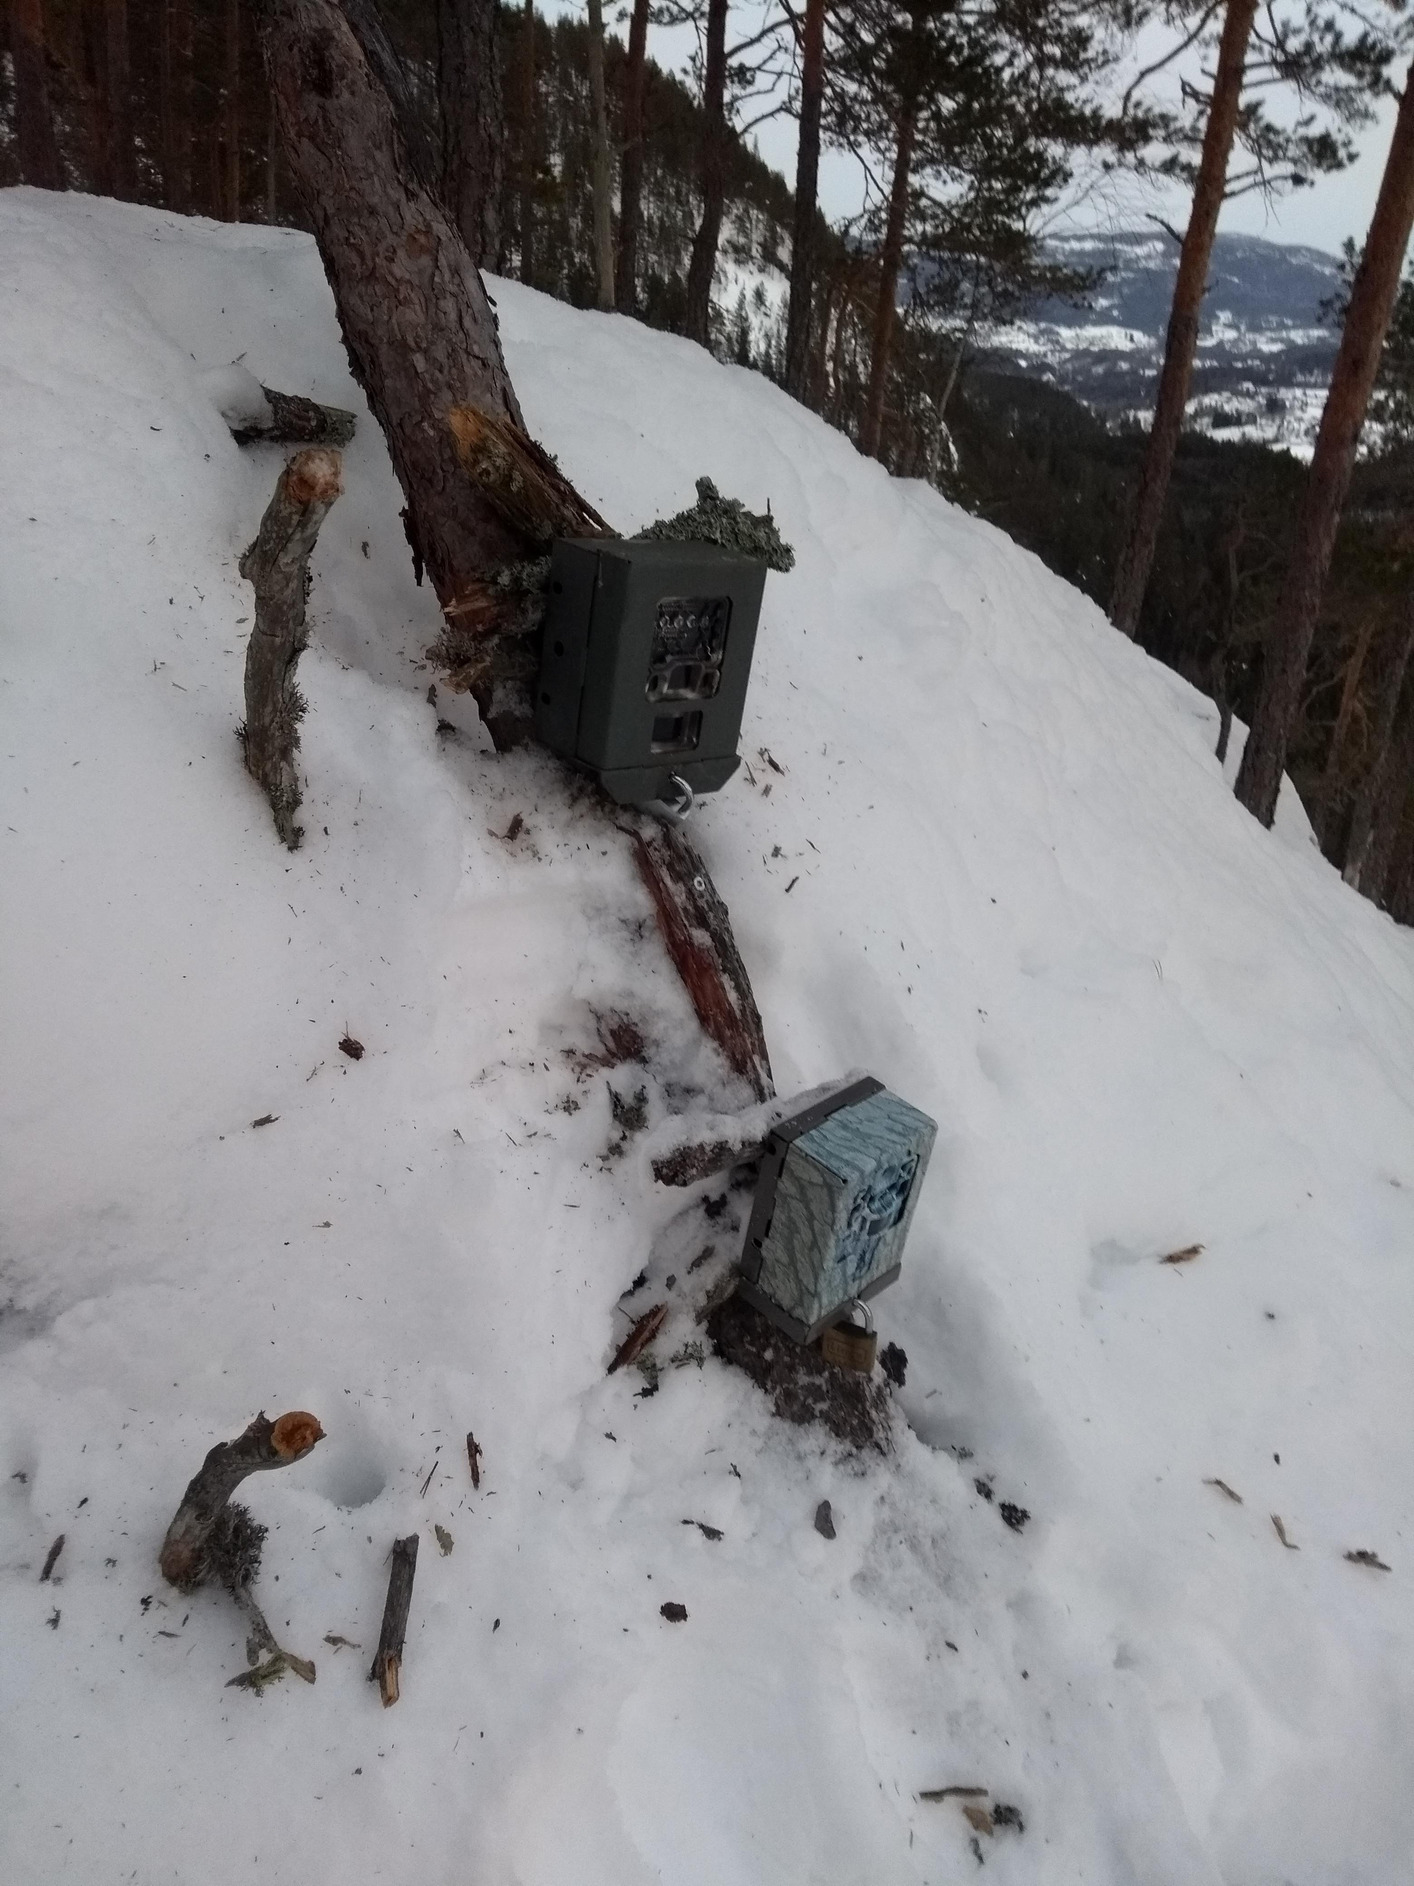

.5 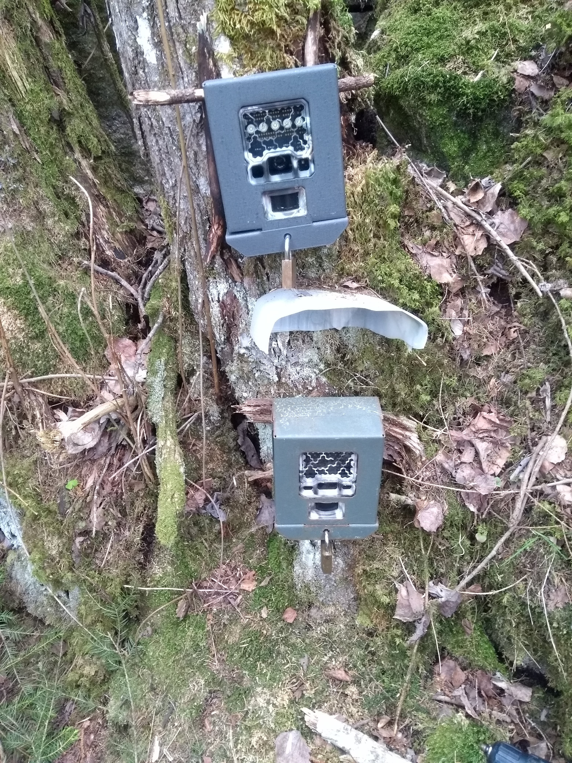

.5 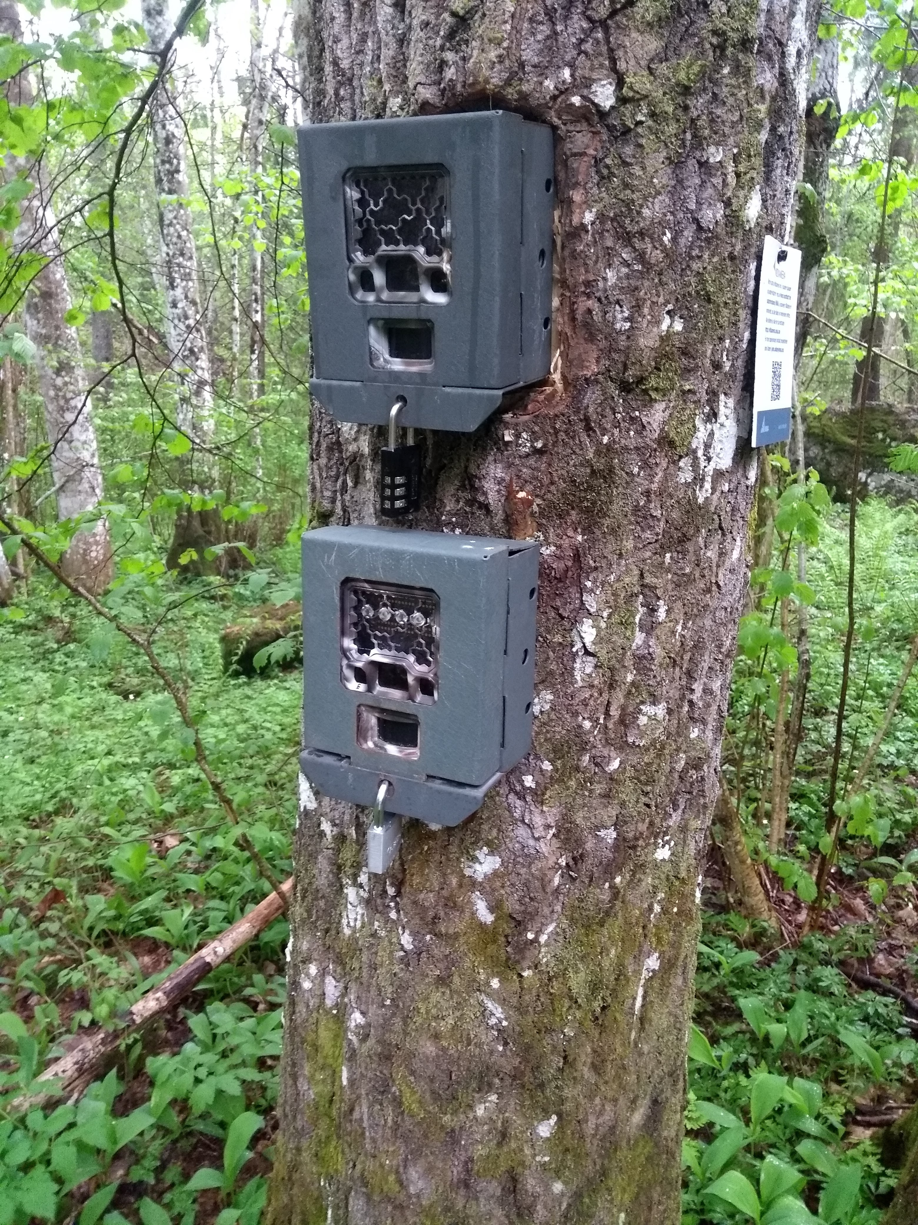

.5 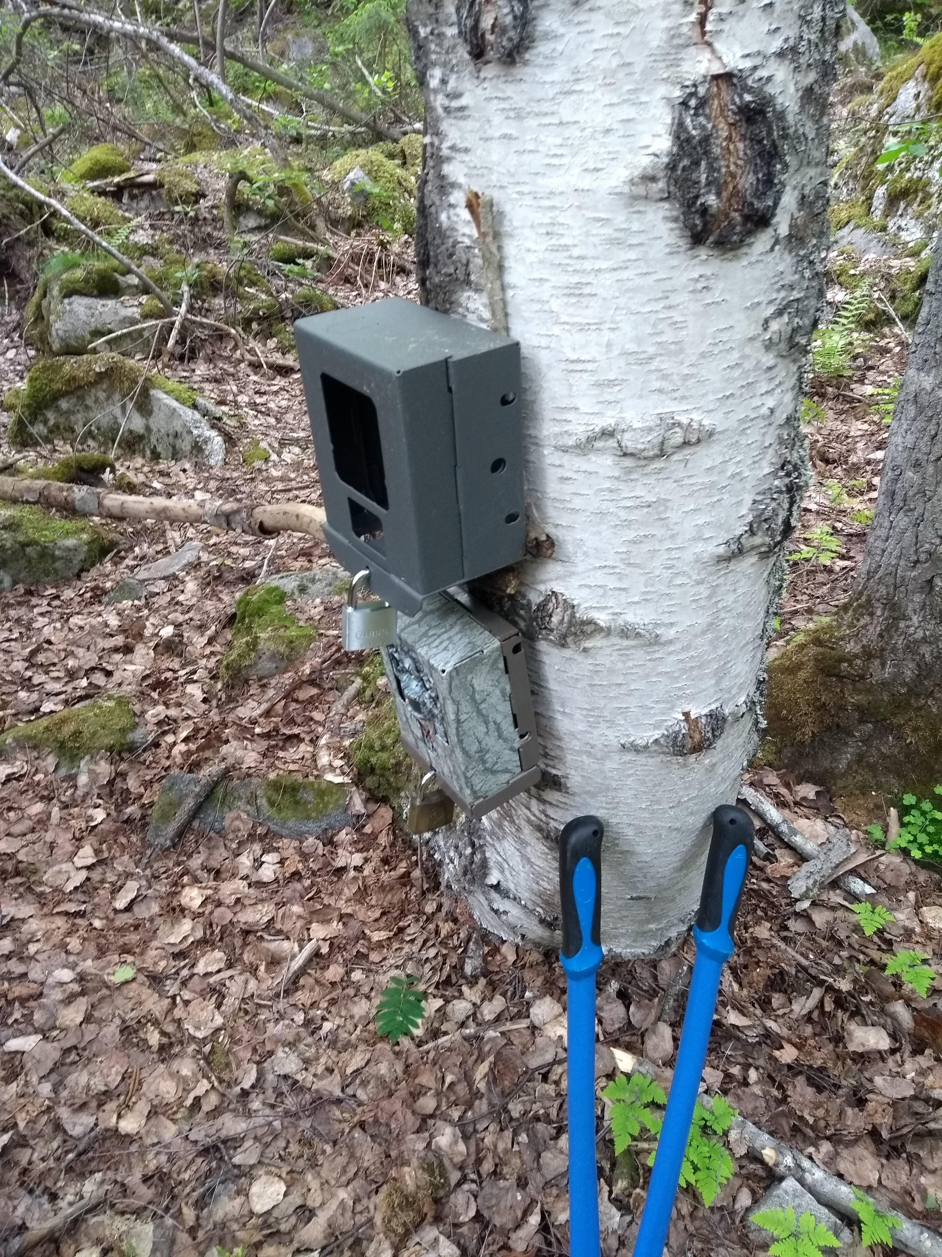

I visited sites of the treatment groups at least once every three months in order to move the wLED cameras. For logistical reasons I visited sites of the control group less often. However, as the cameras were part of other, ongoing projects, they were occasionally visited by workers from NINA to retreive the Secure Digital memory cards (hereby SD Cards) for data. This was mostly the case for sites close to, and south of, Oslo, or rather, the cameras not normally operated by local volunteers.

## Data Collection

As seen in figure [fig:map], there was a correlation between latitude and camera type.

[fig:map]

## Data processing

All SD cards were delivered to NINA for data processing. Firstly, a facial recognition algorithm (FRA) was used to sort all the pictures. Afterwards, a human sorter checks the softwares’ output, confirming all the correct decisions (i.e. species detections) and correcting all the wrong ones. Consequently, the rate of correctly identified species has gone up as the FRA sometimes detect animals that aren’t easily noticed by human sorters (pers.comm. John Odden). NINA’s goal is to fully automate this identification process, which is a request from The Norwegian Data Protection Authority in relation to usage of cameras in densely crowded areas (e.g. parks) (pers.comm. John Odden).

The wLED CTs were considered as external flashes, and so, only the pictures from the preinstalled IR CTs were sorted for species identification. NINA provided me with a data frame containing time stamps for every triggering of each IR CT, including all meta data from the CTs, coupled with predicted species (FRA output, with a confidence number), verified species (by human sorters), number of animals and distance from camera.

Thus, if a moose ruminated in front of a camera for 30 minutes, the data frame would include several detections in sequence. In order to remove autocorrelation in the observations, I defined an event to be any sighting of a species that occured more than 20 minutes after the previous sighting of the same species. Number of individuals was not taken into account. My predictor variable of interest was the three different types of periods, namely IR, wLED and Control periods.

I extracted metadata from all pictures taken by the wLED CTs and used that to define the duration of each wLED period. If a wLED CT stopped working (eg. due to full SD card or empty batteries) before the day I came to move it, the site would have already entered its next IR period. This happened a few times, which can be seen as the times a light blue period starts outside of the shaded areas in figure [fig:timeseries]. If an IR CT stopped working during a wLED period, that period represented a GAP even though the wLED CT still functioned. Thus, the site, and it’s inhabitant animals, would still experience the effect of a white flash up until the start of the IR period. I never experienced that both the IR and the wLED CTs of a site had stopped working at the same time.

When modelling the detection rates I needed periods of similar lengths to each other. Therefore, I divided the control group-cameras into four periods of similar lengths to that of the IR- and wLED-periods (see figure [fig:timeseries]).

In total, 4 sites were removed before the analysis due to technical faults, or alike. 1 CT was removed from the control group, as it turned out to be a white LED camera. 3 CTs were removed from the treatment groups, because of large or frequent gaps due to technical errors, and at one site, ineffective placement of the additional white LED camera.

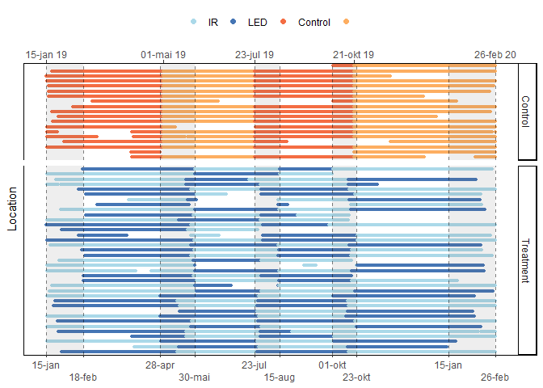

Active camera days Colours indicate the different periods for each site. White spaces indicate gaps where the IR CTs were inactive. Control camera periods were defined in similar lengths to that of the treatment group during analysis. As a result, the first day of control periods are often set at dates far from when I actually visited the site. Shaded areas represent my field work periods. [fig:timeseries]

## Statistical analysis

To test for effects of the white LED flash I used the R programming language (), in the RStudio IDE (), adopting large parts of the tidyverse () and the easystats () frameworks along the way. Complete citation of R packages used are presented in appendix [app:sessinfo].

### GLMM

To test H1 I looked for differences in detection rate per day, using Generalised Linear Mixed Models (GLMM) with the glmer function from the R package lme4 (). I fitted separate models for each species to avoid overly complicated models. Locations that had 0 observations of the modelled species were filtered out before the modelling, but for all locations that had observed the species, all periods were included. The dependent variable was count data (number of observations), and I therefore assumed the error term followed a Poisson distribution ($X∼Pois(λ)$).

I included location ID and week of the year as random effects to account for consistent differences between camera sites and seasonal changes during the year of study. 95% Confidence Intervals (CIs) and p-values were computed using the Wald approximation. I used standardized parameters (mean = 0, SD = 1) to enable comparison of effect sizes.

The main term of interest was time since deployment interacting with type of flash period (formula: n.obs $∼$ time.deploy $*$ flash). For the sites that were equipped with an additional white LED camera, time since deployment starts from the day I visited the camera, and set up/ took down the white LED. The control group’s “day 0” of time since deployment were set at points reflecting the onset of field work each time, in order to obtain periods of similar lengths to that of the white LED-locations.

I trimmed the period lengths down to a reduced maximum length, based on the median length of the IR and white LED periods, to enhance meaningful comparison. Thus, any period exceeding the shortest median length, was trimmed down, as visualized in figure [fig:median_period]. Finally, due to large eigenvalues in the fixed effects, the model failed to converge, and an error message prompted me to rescale variables. Therefore I divided the time since deployment-variable by ten, which solved the error. Consequently, the time axis is shown in days/10, which means that 8 corresponds to 80 days.

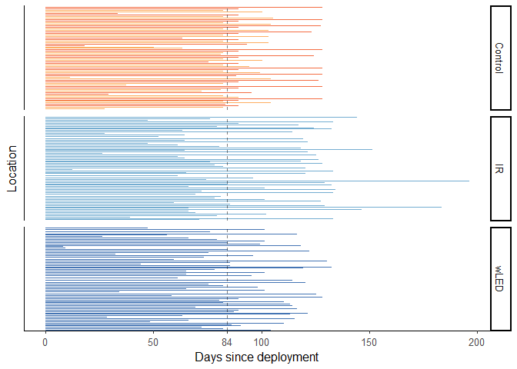

Period lengths Vertical line represents the median IR period length, which was shorter than the median of the other groups. Data superceding the median were trimmed away for the GLMM. [fig:median_period]

If there were any effect of the white LED, the IR period should show a regression to the norm, ie. counteracting the trend during the wLED periods. Thus, if the wLED had a negative slope along the time axis, the IR should have a positive slope. Further, the detection rate at the start of each period, should correspond somewhat to the detection rate at the end of the previous period. Still, that pattern could be skewed to some extent due to my visitation of each location at the start of all IR and wLED periods.

### Equivalence test

I used the standard significance level of $α=.05$, and performed an equivalence test on my model outputs, using the function equivalence_test from the R package parameters ().In an equivalence test, model parameters are tested against a Region of Practical Equivalence (ROPE) as opposed to merely one single mean value, thus accounting for the *effect size* of each parameter. If the parameters estimate and CI falls outside the ROPE, their null hypothesis is rejected. However, if the CI is inside the ROPE, H0 is accepted, no matter if a standard Null Hypothesis Significance Test (NHST) would have deemed it significant.

Inside the function equivalence_test I used the Two One-Sided Tests (TOST) rule, where the confidence interval (CI) is set to $1−2×α$. In my case that gave a narrow CI of 0.90. For models from count data, the residual variance is often used to define the ROPE range. However, the description of the rope_range function from the package bayestestR () states this threshold as “rather experimental” and that the range is probably often similar to the default [-0.1, 0.1] of a standardized parameter (www.easystats.github.io/bayestestR/reference/rope_range.html, accessed 11.3.2021). Hence, I used the default ROPE range which corresponds to a negligible effect size according to Cohen, 1988.

# Results

The type of CT flash had an overall minor effect on detection rates. In general, the control periods (which never had white flashes) had a somewhat lower detection rate than the IR and wLED periods. There were a total of $≈18000$ camera trapping days, which was unevenly distributed between the different periods and period types. Trimming the data according to median period length of IR periods (which was shorter than that of control and wLED periods) evened out the disproportions between the periods (see figure [fig:active days]).

I will present detailed results of all the nine species included in my analyses in order most to least number of events, as shown in figure [fig:events]. Each species is presented with a figure showing activity across time of day, a photo taken with a white LED CT of the species, an equivalence test, and a plot of the marginal means of the fixed effects in the GLMM model, showing the detection rates of all three types of periods (Control, IR and wLED) along a time axis.

.5 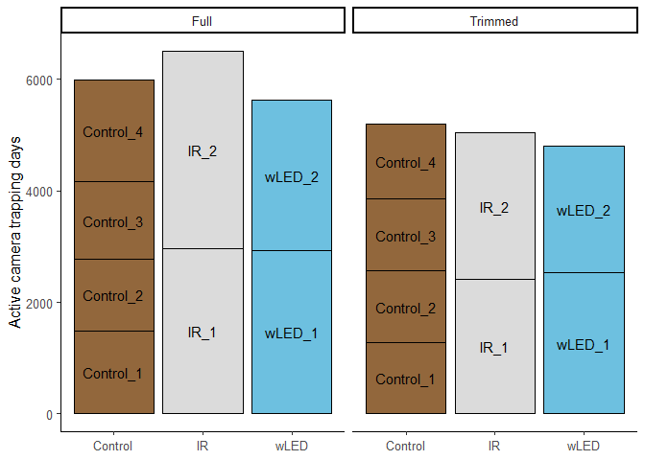

.5 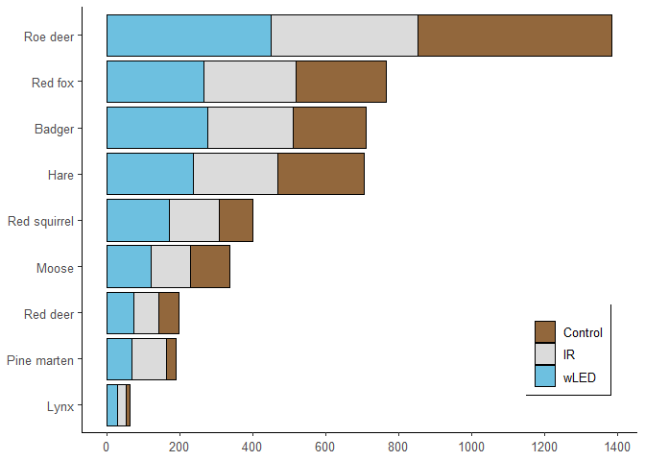

The main effect of LED was positive for most species, although none responded significantly (table [tab:param]).

[tab:param] Model parametersResults of generalised linear mixed effect models on detection rate of species at 56 different locations in south-eastern Norway,

|  |  |  |  |  |  |  |
| --- | --- | --- | --- | --- | --- | --- |
| Species | Parameter | Coefficient | SE | 95% CI | z | p |
| Roe deer | (Intercept) | -2.85 | 0.38 | (-3.58, -2.11) | -7.57 | $<$.001 |
|  | TimeDeploy | -0.05 | 0.02 | (-0.09, -0.01) | -2.24 | 0.025 |
|  | IR | -0.26 | 0.44 | (-1.12, 0.60) | -0.59 | 0.557 |
|  | wLED | -0.13 | 0.44 | (-0.99, 0.73) | -0.30 | 0.761 |
|  | TimeDeploy * IR | 0.02 | 0.03 | (-0.04, 0.08) | 0.71 | 0.476 |
|  | TimeDeploy * wLED | 3.37e-03 | 0.03 | (-0.05, 0.06) | 0.12 | 0.901 |
| Red fox | (Intercept) | -3.44 | 0.26 | (-3.94, -2.94) | -13.40 | $<$.001 |
|  | TimeDeploy | -5.47e-04 | 0.03 | (-0.06, 0.05) | -0.02 | 0.985 |
|  | IR | 0.03 | 0.32 | (-0.59, 0.65) | 0.09 | 0.926 |
|  | wLED | 0.18 | 0.31 | (-0.44, 0.79) | 0.56 | 0.574 |
|  | TimeDeploy * IR | -2.41e-03 | 0.04 | (-0.08, 0.07) | -0.06 | 0.949 |
|  | TimeDeploy * wLED | -0.01 | 0.04 | (-0.08, 0.06) | -0.30 | 0.763 |
| Badger | (Intercept) | -4.79 | 0.39 | (-5.56, -4.02) | -12.15 | $<$.001 |
|  | TimeDeploy | 0.07 | 0.03 | ( 0.00, 0.13) | 1.90 | 0.058 |
|  | IR | 0.27 | 0.42 | (-0.55, 1.09) | 0.64 | 0.523 |
|  | wLED | 0.34 | 0.42 | (-0.48, 1.15) | 0.81 | 0.421 |
|  | TimeDeploy * IR | 7.08e-03 | 0.04 | (-0.07, 0.09) | 0.17 | 0.865 |
|  | TimeDeploy * wLED | 3.93e-03 | 0.04 | (-0.07, 0.08) | 0.10 | 0.922 |
| Moose | (Intercept) | -4.75 | 0.38 | (-5.49, -4.01) | -12.58 | $<$.001 |
|  | TimeDeploy | 9.66e-03 | 0.05 | (-0.08, 0.10) | 0.21 | 0.830 |
|  | IR | -0.04 | 0.44 | (-0.90, 0.82) | -0.09 | 0.927 |
|  | wLED | 0.34 | 0.43 | (-0.51, 1.19) | 0.78 | 0.434 |
|  | TimeDeploy * IR | 0.05 | 0.06 | (-0.07, 0.16) | 0.78 | 0.433 |
|  | TimeDeploy * wLED | -0.01 | 0.06 | (-0.12, 0.10) | -0.19 | 0.849 |
| Red deer | (Intercept) | -5.99 | 0.71 | (-7.39, -4.59) | -8.38 | $<$.001 |
|  | TimeDeploy | -0.10 | 0.06 | (-0.21, 0.02) | -1.56 | 0.119 |
|  | IR | 0.07 | 0.81 | (-1.51, 1.65) | 0.09 | 0.930 |
|  | wLED | -0.60 | 0.82 | (-2.21, 1.02) | -0.72 | 0.469 |
|  | TimeDeploy * IR | 0.06 | 0.08 | (-0.09, 0.22) | 0.80 | 0.424 |
|  | TimeDeploy * wLED | 0.23 | 0.08 | ( 0.07, 0.39) | 2.81 | 0.005 |
| Lynx | (Intercept) | -6.38 | 0.71 | (-7.77, -5.00) | -9.03 | $<$.001 |
|  | TimeDeploy | -0.21 | 0.14 | (-0.48, 0.06) | -1.52 | 0.128 |
|  | IR | -0.49 | 0.83 | (-2.11, 1.14) | -0.59 | 0.558 |
|  | wLED | -0.14 | 0.83 | (-1.76, 1.48) | -0.17 | 0.867 |
|  | TimeDeploy * IR | 0.24 | 0.16 | (-0.08, 0.56) | 1.48 | 0.140 |
|  | TimeDeploy * wLED | 0.25 | 0.16 | (-0.07, 0.57) | 1.54 | 0.124 |
| Hare | (Intercept) | -4.29 | 0.43 | (-5.13, -3.45) | -10.05 | $<$.001 |
|  | TimeDeploy | 0.04 | 0.03 | (-0.03, 0.10) | 1.13 | 0.258 |
|  | IR | 0.24 | 0.50 | (-0.75, 1.23) | 0.47 | 0.636 |
|  | wLED | 0.11 | 0.51 | (-0.89, 1.10) | 0.21 | 0.835 |
|  | TimeDeploy * IR | -0.05 | 0.04 | (-0.13, 0.03) | -1.28 | 0.199 |
|  | TimeDeploy * wLED | 8.95e-04 | 0.04 | (-0.08, 0.08) | 0.02 | 0.983 |
| European Pine Marten | (Intercept) | -6.38 | 0.57 | (-7.50, -5.27) | -11.20 | $<$.001 |
|  | TimeDeploy | 0.10 | 0.09 | (-0.09, 0.28) | 1.01 | 0.314 |
|  | IR | 1.67 | 0.61 | ( 0.47, 2.87) | 2.73 | 0.006 |
|  | wLED | 0.76 | 0.64 | (-0.49, 2.01) | 1.20 | 0.232 |
|  | TimeDeploy * IR | -0.11 | 0.11 | (-0.32, 0.09) | -1.08 | 0.280 |
|  | TimeDeploy * wLED | 0.02 | 0.11 | (-0.19, 0.24) | 0.22 | 0.828 |
| Red squirrel | (Intercept) | -5.72 | 6.21e-04 | (-5.72, -5.72) | -9211.38 | $<$.001 |
|  | TimeDeploy | 0.08 | 6.21e-04 | ( 0.08, 0.08) | 132.04 | $<$.001 |
|  | IR | 0.83 | 6.21e-04 | ( 0.83, 0.83) | 1334.43 | $<$.001 |
|  | wLED | 0.51 | 6.21e-04 | ( 0.51, 0.51) | 818.92 | $<$.001 |
|  | TimeDeploy * IR | -0.18 | 6.21e-04 | (-0.18, -0.18) | -286.42 | $<$.001 |
|  | TimeDeploy * wLED | -0.02 | 6.21e-04 | (-0.02, -0.02) | -26.66 | $<$.001 |

## Roe deer

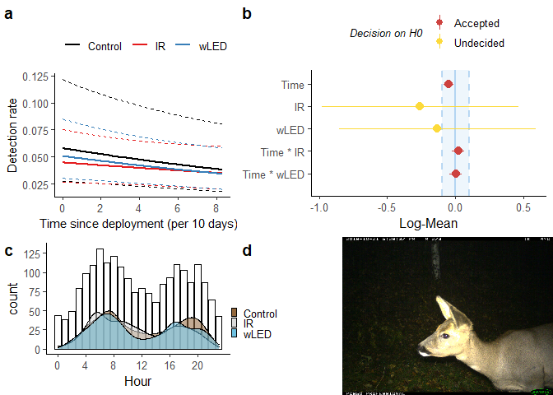

Roe deer a) The predicted detection rate of roe deer for each level of the flash-variable. Confidence intervals (CI) represented by dotted lines.  
b) Model parameters presented in an equivalence test. ROPE is set to $±$ 0.1 Log-Mean, $CI=1−2×α$.  
c) Bars represent the raw count of total roe deer detections per hour of the day, and density curves show the overall pattern for each group.  
d) LED-CT photograph of a roe deer. The deer passed the camera repeatedly and often stopped in front of the flashing light

Roe deer was the most common species in my dataset, with a total number of 1709 events. The species was detected at all times of day, with marked peaks of activity during the twilight hours. Looking at the density curves in figure [fig:raadyr]c, the overall activity pattern was consistent between the three types of periods (control, IR and wLED). The detection rates were also similar, as demonstrated in figure [fig:raadyr]a.

The GLMM explaining variation in detection rate had a substantial explanatory power (conditional R2 = 0.45), but the part related to the fixed effects alone (marginal R2) was just 0.002. In other words, most of the explained variation in detection rate was due to seasonal changes and variation between the different camera sites captured in the random terms. In a standard null hypothesis significance test (NHST) no parameters were significant.

The equivalence test in figure [fig:raadyr]b accepted the validity of H0 (that there were no effect) for the effect along the time axis in all three types of periods. However, the detection rate varied a lot in all periods, which hindered a decision on the main effect of IR and wLED periods.

## Red fox

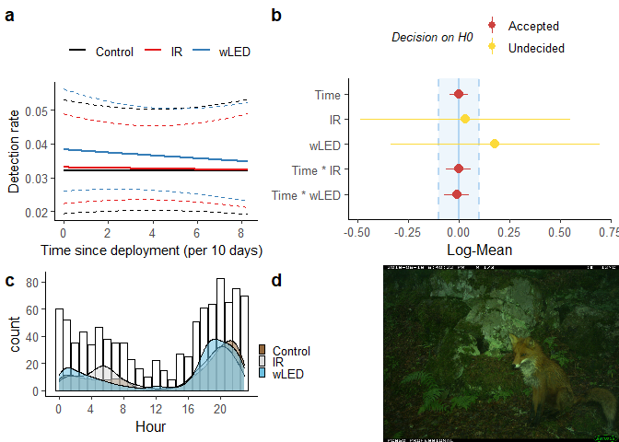

Red fox a) The predicted detection rate of red foxes for each level of the flash-variable. Confidence intervals (CI) represented by dotted lines.  
b) Model parameters presented in an equivalence test. ROPE is set to $±$ 0.1 Log-Mean, $CI=1−2×α$.  
c) Bars represent the raw count of total fox detections per hour of the day, and density curves show the overall pattern for each group.  
d) LED-CT photograph of a red fox. The fox stopped in front of the flashing camera and waited for a following individual before they continued.

The red fox was my second most common species with 913 events. The red fox was also active during the whole day, but with a more pronounced peak in the late evening continuing untill the break of day, as visualised in figure [fig:rev]c. The overall pattern was similar between each group (Control, IR, wLED), and the overall effect of wLED was minor.

The GLMM explaining variation in detection rate of red fox had a substantial explanatory power (conditional R2 = 0.19), but the part related to the fixed effects alone (marginal R2) was just 0.001. In other words, most of the explained variation in detection rate was due to seasonal changes and variation between the different camera sites captured in the random terms. No parameters were significant in a standard NHST, and considering the equivalence test in figure [fig:rev]b, the effect of time was practically equivalent for all types of periods. However, the large variation in the main effect of IR and wLED hinders any decision on H0, although the estimate of wLED (0.18) hints at an attractant effect.

## Badger

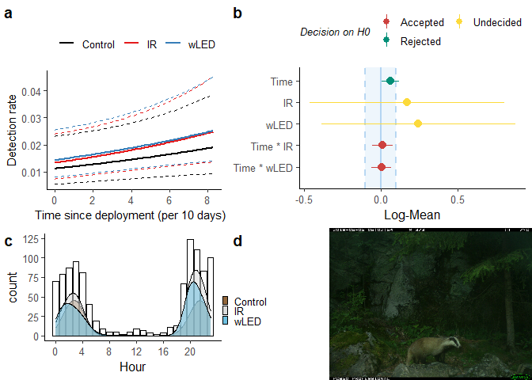

For badger, the model explaining variation in detection rate has a substantial explanatory power (conditional R2 = 0.42), but the part related to the fixed effects alone (marginal R2) is just 0.006.

## Hare

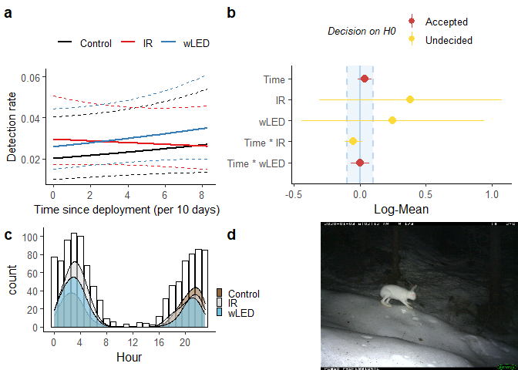

## Red squirrel

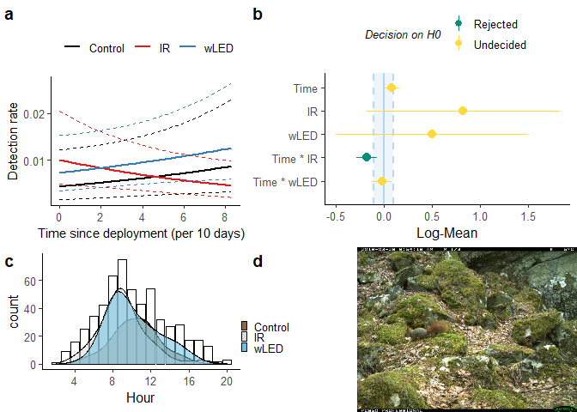

## Moose

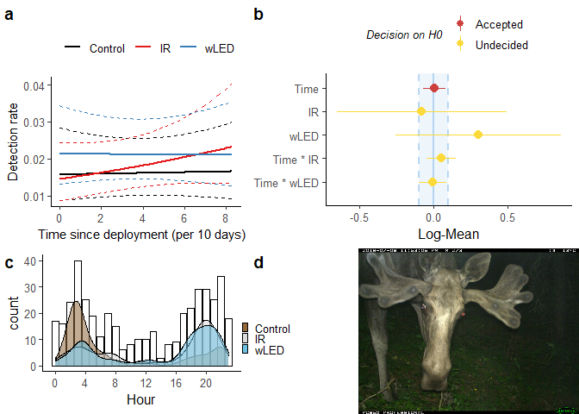

## Red deer

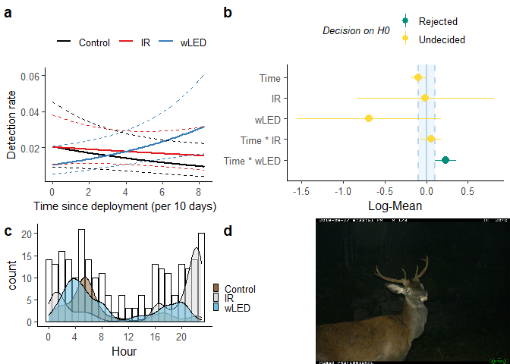

Red deer

## Pine marten

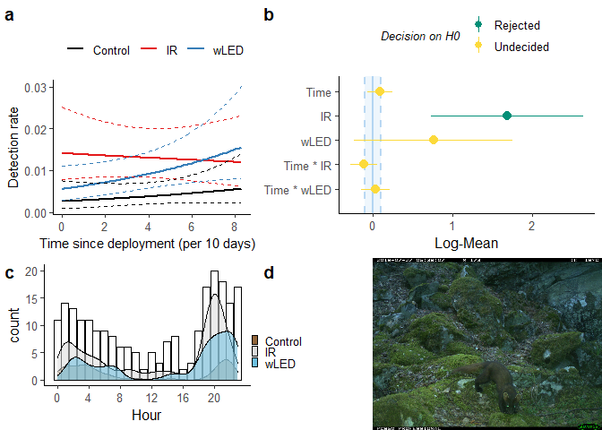

Pine marten

## Lynx

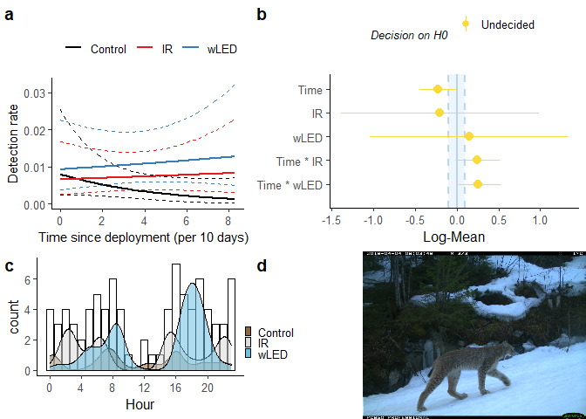

Lynx

# Discussion

In the example of Scandlynx, CTs have been introduced as a more reliable survey method than snow track counts of the Eurasian lynx in Norway. The CTs bring in a lot of useful information about the lynx, but it is also triggered by the rest of the mammal species in the area. Thus they provide a lot of information of other species as well, which would be a shame to throw away.

As I have shown in the density plots from my raw data, I am able to record the daily activity pattern of these other mammal species, and (all/most/some/none) matched the activity-patterns that I expected out from reading about their known activity patterns.

The decisions on setup of scandlynx CTs are solely based on maximizing the chances of detecting lynx, and on gathering as much information about individual lynx as possible. My aim has been to see if the decision on whether or not to use a white LED flash affects the detection rates of other species. Beddari (2018) showed that grey wolfs shy away from sites equipped with white LED CTs. They scared away from the site immediately, and were (only redetected in TK instances / never redetected). For lynx the story was different. One lynx was recorded sleeping in front of a white LED CT, (and didn’t seem to affect the chance of redetection?). Heinrich etal. (2020) investigated the detection rates of roe deer and red deer in Blackforest(TK?), Germany, but were unable to conclude on the effect of white light as they used a xenon white flash, that had a cool down of at least 22 seconds after each photo was taken.

Heinrich etal. (2020) also set up cameras at new sites every time, and for shorter periods than me ( 20 days?)I used already established CT sites with red-glow and no-glow Infra-Red flashes (henceforth referred to as IR CTs). Then I set up an additional white LED CT 5-20 cm above the preinstalled IR CTs in alternating 3 month periods. Thus, from the wild animals’ perspective, the novelty was twice the sound made from the camera shutters, one additional box on a tree, above the other box that had been there for a while, and, during the night, (at least) three flashes of white light. For the animals that were familiar with a weird looking box on that specific tree, which made a strange noise, already, maybe they weren’t especially surprised, as they were expecting something going on around that tree anyway.

Til konklusjonen: Hvordan besvares problemstillingen? Er hypotesen styrket, svekket eller falsifisert? Ikke trekk inn momenter som ikke har vært nevnt tidligere i teksten (under Introduksjon, Metode eller Resultat). Hvis studien ikke gir grunnlag for å konkludere, kan du avslutte med en oppsummering.

Som Atle har sendt til diskusjon:

..general results.. Out of all nine species included in my analysis, only the red squirrel showed a diurnal pattern. Roe deer and pine marten were active throughout the day, but both had their peaks in the twilight hours.

..roe deer.. Although the figure doesn’t tell us if each photo was taken before or after sunrise/sunset, there seems to have been a significant portion taken during the twilight. Thus, it has been dark enough that the white LED has been triggered. However, there were little activity during the middle of the night, when the light stimuli would have been at it’s strongest. Consequently, most photos were taken when the flash stimuli wasn’t at it’s strongest. Just to repeat myself, the overall pattern stayed the same for all periods, which at least tells us that any effect of the flash seems to have been small.

..roe deer.. – equivalence testing Looking at figure [fig:raadyr]b, the main effect of the IR and LED periods have a wide CI, which makes us unable to conclude on the groups’ true effect sizes. IR is estimated to be within the Region of Practical Equivalence (ROPE), and LED is estimated to be outside, but the large variation still present in the data prevents a conclusion. Considering the time variable, and it’s interaction, all are within the ROPE, and the test tells us to accept it’s practical equivalence to H0, namely that there is no effect. Still, when interpreting a continuous variable as this, it is worth considering it’s scale. I scaled my time variable to represent 10 day intervals, in order for the model to converge. That means the estimated effect of time since deployment is ten times larger than it would have been if it remained as 1 day intervals. Conversely, had I scaled it to represent the whole span of 84 days, the estimated effect and confidence interval would have been 8.4 times larger than what it is now (0.4), and so would it’s confidence interval. The equivalence test would be undecided on the effect of time since deployment.

Seeing as many experiments are set up with a period length much shorter than mine, it seems reasonable to aim for a time unit which would translate well to these more common lengths. In they set up cameras for periods of  20 days,and could therefore not have detected any effects on a time scale of 84 days.

– forts. Nevertheless, the control-group is what I am using as a reference point to what is normal. What I am interested in investigating is whether, and to what extent, the LED group deviates from the control group. As mentioned, the main effect is non-significantly positive compared to both the control and the IR. The same is true along the time axis. Both the slope for IR and LED are practically equivalent to the slope for control. Interesting to note, is however, that the slopes cross each other, which is what they would do if there is an effect of the LED, ie. that the IR periods counteract the effect of the LED periods.

## Model performance

The models explaining variation and whatnot, mostly due to the random terms. This is to say that after having accounted for variations between camera sites, and seasonal fluctuations, there still was a lot of variation in the dataset left to explain, and the period-categories of “Control”, “IR” and “LED” interacting with time since deployment didn’t explain much of it. method: Using the performance package i checked various assumptions, and all held up Overdispersion, zero-inflation and singularity all held up in every model.